List Group Members: | TOTAL MARKS (40)
1.
2.
3.
4.

-EVALUATIONS-

Part A: Statistical Analysis: Overall Execution
Item | Mark
Hypothesis statement | 1 | 2 | 3 | 4
Execution of test | 1 | 2 | 3 | 4
Interpretation of results | 1 | 2 | 3 | 4
Conclusion and discussion | 1 | 2 | 3 | 4
Total | [ /16] * 8 =
Part B: Statistical Analysis: Selected Test
Compulsory
Item | Mark
- sample test or  - sample test | 1 | 2 | 3 | 4
Correlation | 1 | 2 | 3 | 4
Regression | 1 | 2 | 3 | 4
Optional (Choose at least 1)
Goodness of fit test | 1 | 2 | 3 | 4
Chi Square test of  independence | 1 | 2 | 3 | 4
Total | [ /16] * 12 =

Part C: Format & Content of Report
Item | Mark
Introduction | 1 | 2 | 3 | 4
Focus on topic (Content) | 1 | 2 | 3 | 4
Conclusion (Organization) | 1 | 2 | 3 | 4
Grammar & Spelling  (Conventions) | 1 | 2 | 3 | 4
Total | [ /16] * 10 =
Part D: Video Presentation / Recorded Presentation
Item | Mark
Content Accuracy | 1 | 2 | 3 | 4
Sequencing of Information | 1 | 2 | 3 | 4
Effectiveness | 1 | 2 | 3 | 4
Delivery | 1 | 2 | 3 | 4
Videography Clarity | 1 | 2 | 3 | 4
Total | [ /20] * 10 =

Reference – Elements of Rubric:
Part A: Statistical Analysis (Overall Execution)

CATEGORY | 4 | 3 | 2 | 1
Hypothesis | Null and alternative | Null and alternative | Null and alternative | Either one of the
statement | hypotheses stated | hypotheses stated | hypotheses not stated | hypothesis statement is
 | correctly in words | correctly in | in mathematical terms | not stated.
 | AND in mathematical | mathematical terms. | or stated incorrectly
 | terms.
Execution of | For required test: | Three of the four | Statistical test not | Statistical test was
test | 1) test statistic is | criteria at left are | conducted or reported | incomplete and not
 | reported | satisfied | correctly | reported
 | 2) test statistic is
 | accurate
 | 3) p value is reported
 | 4) p value is
 | appropriate
Interpretation of Results | Results are interpreted correctly and consistently with respect to:  - significance  - rejection of null hypothesis  - real world conclusion about subject being studied | Interpretation of p- values satisfies all criteria at left | p-values not interpreted correctly or consistently | p-values not interpreted
 | AND includes clear discussion of significance levels
Conclusion | Discussion of results | Adequate | Discussion draws | Implications of results
and | is insightful; adds | discussion of results | unwarranted | not discussed; no
Discussion | meaning and | and their practical | conclusions or uses | attempt to explain
 | significance to the | implications; | inappropriately certain | findings.
 | report; no | reasonable | language (e.g., “we
 | unwarranted | explanation of | proved”, “our hypothesis
 | conclusions. | findings offered; no | is true”)
 |  | unwarranted
 |  | conclusions.

Part B: Statistical Analysis (Selected Test)

CATEGORY | 4 | 3 | 2 | 1
Statistical | Correct test is | Appropriate | Inappropriate statistical | statistical tests
Analysis: | conducted and | statistical test is | tests conducted OR | conducted wrongly OR
Selected | explanation of all | conducted correctly | statistical tests not | no explanation were
Test | details of test is | and explained | explained well | presented
 | thorough, articulate, | adequately
 | and precise

Part C: Format & Content of Paper
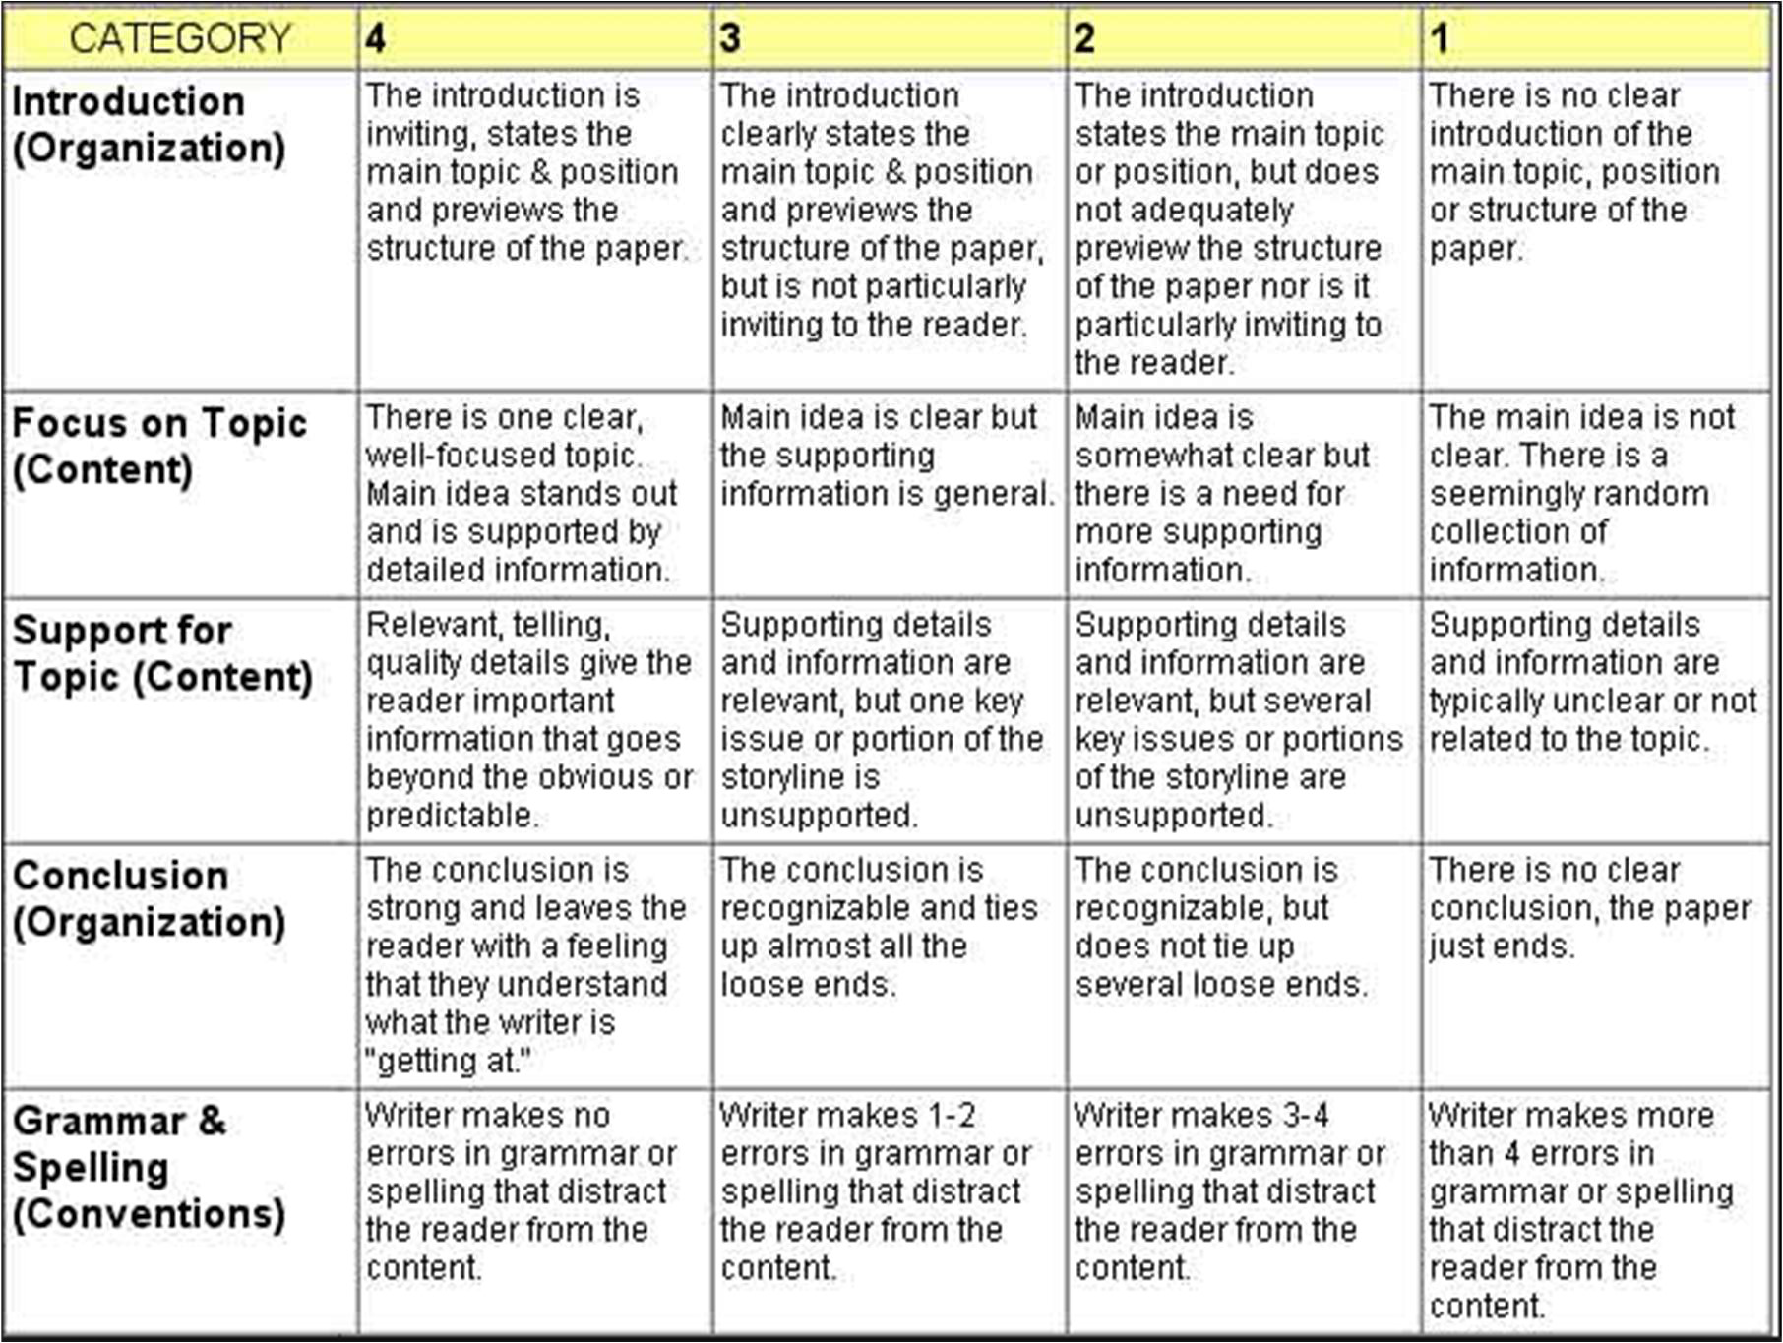

Part D: Video Presentation/Recorded Presentation

CATEGORY | 4 | 3 | 2 | 1
Content | All content | Most of the | The content is | Content is
Accuracy | throughout the | content is | generally | in generally
 | presentation is | correct but | correct, but | confusing or
 | correct. There | there is one | one piece of | has more
 | are no factual | piece of | information is | than one
 | mistakes. | information that | clearly | factual
 |  | might be | inconsistent or | mistake.
 |  | incorrect. | incorrect.
Sequencing of | Communication | Most information | Some | There is no
Information | of facts is | is organized in a | information is | apparent plan
 | organized in a | comprehensible, | logically | for the
 | comprehensible, | logical | sequenced. | organization of
 | logical way. It is | way. | An | information.
 | easy to predict |  | occasional
 | the type of |  | item of
 | material that |  | information
 | might be on the |  | seems out of
 | video. |  | place.
Effectiveness | Video includes | Project includes | Video is | Video is
 | enough material | most material | missing | missing several
 | to give a deep | required to give | more than two | key
 | understanding | an | key points. It | points and
 | of the case | understanding | would make

 | study. It is a highly effective study. | of the case study,  but is lacking one or two key points. It is a  sufficient study. | an incomplete study. | has inaccuracies that make it a poor study.
Delivery | Presentation is | Presentation is | Presentation is | Presentation is
 | very well | well prepared. | somewhat | clearly
 | prepared and | Good voice | prepared. | unprepared.
 | delivers results in | volume, tone | Good voice | Poor voice
 | a clear and | and pacing. | volume, tone | volume, tone
 | concise | Gestures | and pacing. | and pacing.
 | manner. | supported | Some | Inappropriate
 | Volume, pacing | overall | appropriate | gestures which
 | and gestures | presentation. | gestures that | detracted
 | contribute |  | supported the | from the
 | maximally to the |  | presentation. | presentation.
 | presentation.
Videography | The overall | Most of the | The quality of | The quality of
Clarity | quality of the | quality of the | the video is | the video and
 | video and the | video and the | not very good | the focus is not
 | focus is | focus is | but the overall | very good.
 | excellent. | excellent. | focus is
 |  |  | excellent.

